Experiment Name : Write a Matlab program to show procedure of double side band suppressed carrier demodulation

Objective :

Objective is to learn how a perform double side band suppressed carrier modulation

Code :

clc

clear all

fs = 1000 ;

n = 1001;

wn=0.02;

[b,a]=butter(2,wn);

msa = input('enter message amplitude : ');

csa = input('enter carrier amplitude : ');

fm = input('enter message frequency : ');

fc = input('enter carrier frequency : ');

m = msa/csa ;

t = 0:0.001:1 ;

w1 =(2 \* pi \* fm \* t);

w2 = ( 2 \* pi \* fc \* t ) ;

%---------------------------------

ms = msa \* sin(w1) ; % message signal

%plotting message signal

subplot(5,1,1);

plot(t,ms);

title('message signal');

%plotting carrier signal

cs = sin(w2) ;

subplot(5,1,2);

plot(t,cs);

title('carrier signal');

dsbsc = csa \* m.\* sin(w1).\*sin(w2);

subplot(5,1,3);

plot(t,dsbsc);

title('modulated');

%noise

noise=randn(1,n) ;

scale=(var(dsbsc)/var(noise))\*3.16;

%scale=(var(vsig)/var(noise))\*3.16;

dsbsc = dsbsc+ noise\*scale ;

subplot(5,1,4);

plot(t,dsbsc);

title('noise');

v1=cs.\*dsbsc;

vout=filter(b,a,v1);

subplot(5,1,5);

plot(t,vout,'c');

Output :

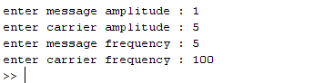

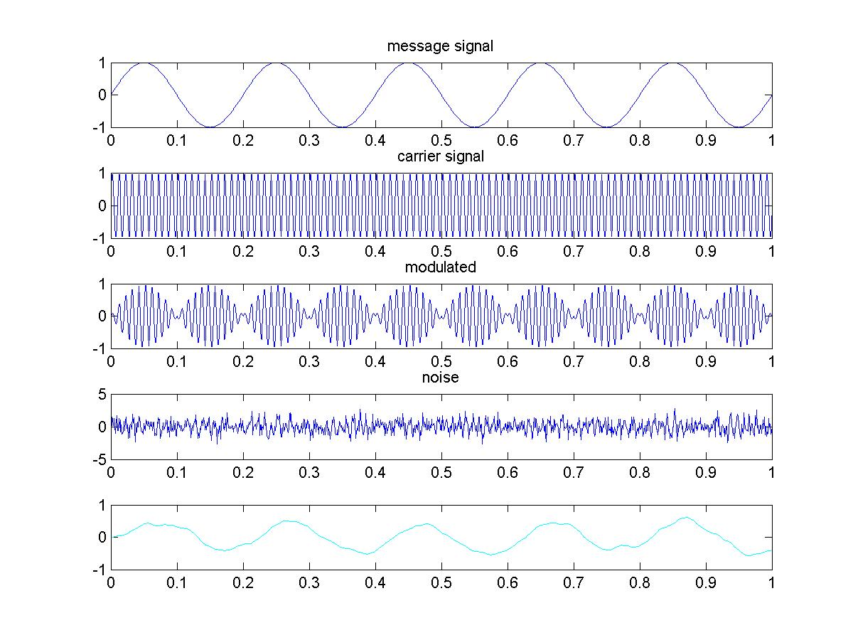

Conclusion :

In this lab we have come to know how to perform double side band suppressed carrier modulation .We have to add carrier signal and then noise to the signal after that we demodulated the signal again , this will be of great help in future work .